**Group 6 - Anh Nguyen, Sarvamangala Nambiar, Pujan Patel**

## Results and Discussion

1. **Variance-Co-Variance matrix**

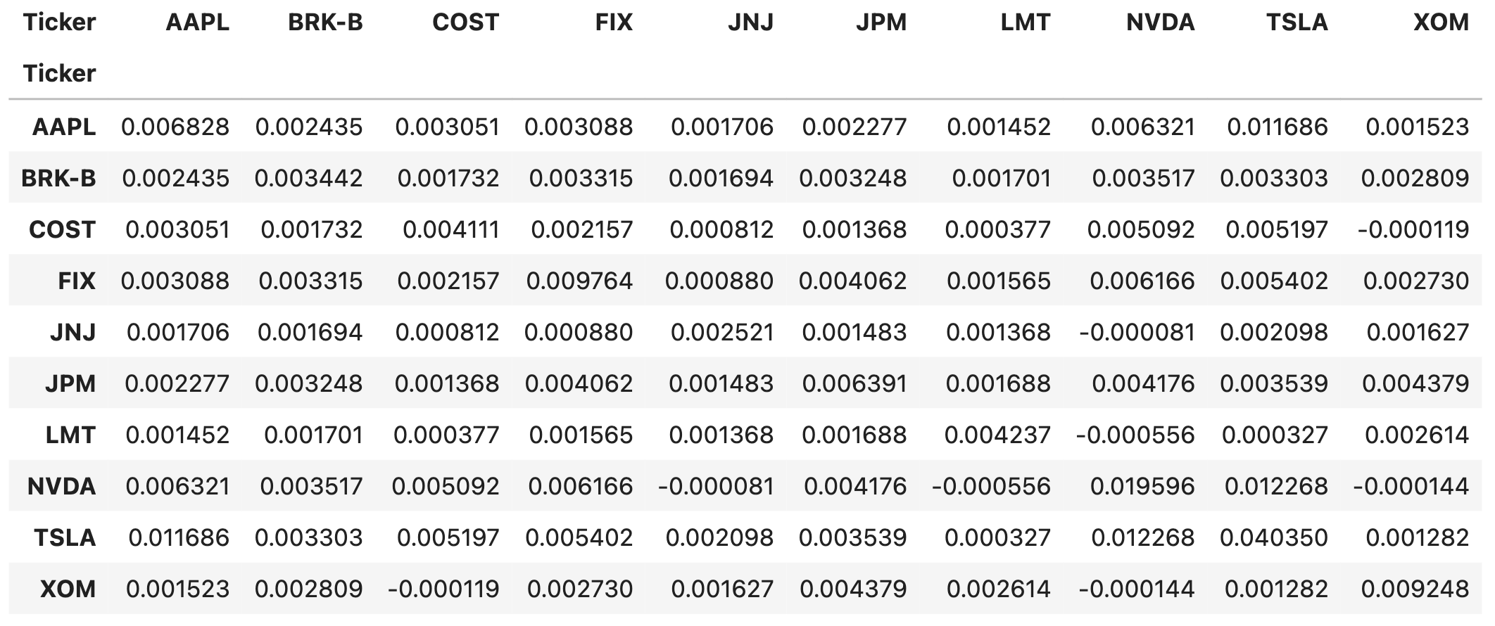

1. **Compare the Beta with Yahoo’s betas**

|  |  |  |
| --- | --- | --- |
| **Stock** | **CAPM beta** | **Yahoo Finance beta** |
| AAPL | 1.194633 | 1.240 |
| NVDA | 1.643941 | 1.657 |
| XOM | 0.872150 | 0.880 |
| COST | 0.761936 | 0.789 |
| TSLA | 2.069860 | 2.295 |
| BRK-B | 0.858081 | 0.871 |
| JNJ | 0.480121 | 0.518 |
| JPM | 1.116842 | 1.091 |
| LMT | 0.448991 | 0.481 |
| FIX | 1.066398 | 1.130 |

The betas of the stocks we calculated are similar to Yahoo Finance’s betas if rounded up to one decimal but slightly different from two decimals or more. This minor discrepancy might be due to the different inputs we use for the regression compared with Yahoo Finance’s. For example, we use the performance SPY (an ETF) as the market portfolio benchmark while Yahoo could have used the performance of S&P500 (an index) as the benchmark. The discrepancy might also come from the difference in the return calculation: we used log-return to calculate excess returns, while Yahoo Finance could have used simple returns instead.

1. **Is the alpha statistically significant at 95%?**

|  |  |  |
| --- | --- | --- |
| **Stock** | **CAPM alpha** | **CAPM alpha p-value** |
| AAPL | 0.009998 | 0.164158 |
| NVDA | 0.036599 | 0.014415 |
| XOM | 0.001576 | 0.888764 |
| COST | 0.010316 | 0.123997 |
| TSLA | 0.023145 | 0.305774 |
| BRK-B | 0.002404 | 0.627025 |
| JNJ | -0.000875 | 0.880213 |
| JPM | -0.001350 | 0.849944 |
| LMT | 0.002275 | 0.777998 |
| FIX | 0.023830 | 0.030239 |

Out of 10 stocks in our portfolio, only two stocks have statistically significant alpha: NVDA and FIX, meaning these are the only two stocks that outperform the predictions by factors consistently. Furthermore, the aphas of FIX and NVDA are both significant in value (around 2.4% and 3.7% respectively). The significant alphas of NVDA and FIX could be explained by a combination of sector trends, management quality and competitive positioning.

While AAPL (Apple) and TSLA (Tesla) have shown remarkable growth in absolute terms over the last two years, their alphas are not statistically significant (p-values of 0.1642 and 0.3058, respectively). This implies that their strong returns can be largely attributed to their market exposure (beta), rather than consistent outperformance over CAPM predictions.

**XOM** (Exxon Mobil), despite being a strong performer during energy price surges, has an insignificant alpha, indicating its performance aligns closely with CAPM predictions. Defensive stocks like **JNJ** (Johnson & Johnson) and **LMT** (Lockheed Martin) have low betas (**0.48** and **0.45**, respectively) and negligible alphas, reflecting their role as stable, low-risk investments.

1. **Discuss how new factors affect alpha**

|  |  |  |
| --- | --- | --- |
| **Stock** | **4-Factor alpha** | **4-Factor alpha p-value** |
| AAPL | 0.009608 | 0.145391 |
| NVDA | 0.035367 | 0.007266 |
| XOM | 0.003010 | 0.737819 |
| COST | 0.009776 | 0.113690 |
| TSLA | 0.026976 | 0.190960 |
| BRK-B | 0.001264 | 0.773417 |
| JNJ | -0.001957 | 0.731809 |
| JPM | -0.000119 | 0.981896 |
| LMT | 0.001381 | 0.854871 |
| FIX | 0.022317 | 0.038889 |

With three new factors added to the model, FIX and NVDA are still the only two stocks that have statistically significant alphas. For FIX, the addition of SMB, HML, and MOM explains a portion of the alpha in the CAPM model, resulting in a slightly lower alpha in the four-factor model, but still statistically significant. For NVDA, however, the coefficients of SMB, HML were negative, meaning it is negatively exposed to these two factors.

In fact, the p-value of the NVDA alpha is even lower than in CAPM, suggesting that its alpha is even more consistent.

1. **Compare expected SR of SIM with SPY**

|  |  |
| --- | --- |
| **Sharpe Ratio** | |
| **SIM** | **0.32906** |
| **Market** | **0.19697** |

The SIM portfolio significantly outperforms the market (SPY) in terms of risk-adjusted returns, with an SR approximately 1.67 times higher than SPY. This suggests that the portfolio constructed using the Single Index Model provides more efficient returns for the level of risk taken. This could be explained by the construction of SIM, where-in, the weights alpha and tracking error, allowing it to exploit securities with higher expected returns and lower systematic risk compared to SPY.

SIM being a combination of active (10 stocks) and passive (SPY), provides a much better performance on a risk-adjusted basis by leveraging the active component to generate alpha while still retaining exposure to the market portfolio for systematic returns.

1. **Compare SR of tangent with sim**

The Tangent portfolio has Sharpe ratio of **0.82**, while the Single Index Model portfolio has a Sharpe ratio of **0.33**. In other words, the Tangent portfolio has a significantly higher Sharpe ratio than the Single Index Model.

Theoretically, the Markowitz model is superior to the Single Index Model because it considers total risk of a stock while the Single Index Model oversimplifies the stock risk profile by assuming that risk is fully characterized by betas. When allocating stocks in a portfolio, the Markowitz model emphasizes how covariance is the key factor in creating a superior risk-adjusted return portfolio (i.e. diversification). With only a few assumptions, the model provides a comprehensive illustration of mean-variance portfolio construction. On the other hand, the Single Index Model only concerns stock covariance with the market since it assumes market risk is the only risk factor that matters. As a result, the Single Index Model tends to underestimate idiosyncratic risks.

Because we are working with only 10 stocks, the complexity of the Markowitz model is not an issue compared to the Single Index Model. If the number of stocks becomes 10,000 instead, the number of inputs grows exponentially, and the Markowitz will become much less efficient than the Single Index Model. As a result, the drawbacks of the Markowitz model are outweighed by the benefits in this case.

1. **Compare SR of 14 and 16:**

The Sharpe ratio from 14 and 16 is equal because the weight of each stock in the portfolio doesn’t change with the margin ratios. As a result, the return and risk of the portfolio doesn’t change, and neither does the Sharpe ratio.